Cal Poly Pomona

CS470 Game Development

Spring Quarter

2017

\*\*\*\*\*\*\*\*\*\*\*\*\*\*\*\*\*\*\*\*\*\*\*\*\*\*\*\*\*\*\*\*\*\*\*\*\*\*\*\*\*\*\*\*\*\*\*\*\*\*\*\*\*\*\*\*\*\*\*\*\*\*\*\*\*

Documentation type: Post Mortem

Project:

Team: BaDkINgZ

Members: Mahmudur Khan,

Nathaniel Krueper,

Benjamin Krueper,

Chu Yiu Cheung,

Ian Stodart

Professor: Tony Diaz

\*\*\*\*\*\*\*\*\*\*\*\*\*\*\*\*\*\*\*\*\*\*\*\*\*\*\*\*\*\*\*\*\*\*\*\*\*\*\*\*\*\*\*\*\*\*\*\*\*\*\*\*\*\*\*\*\*\*\*\*\*\*\*\*\*

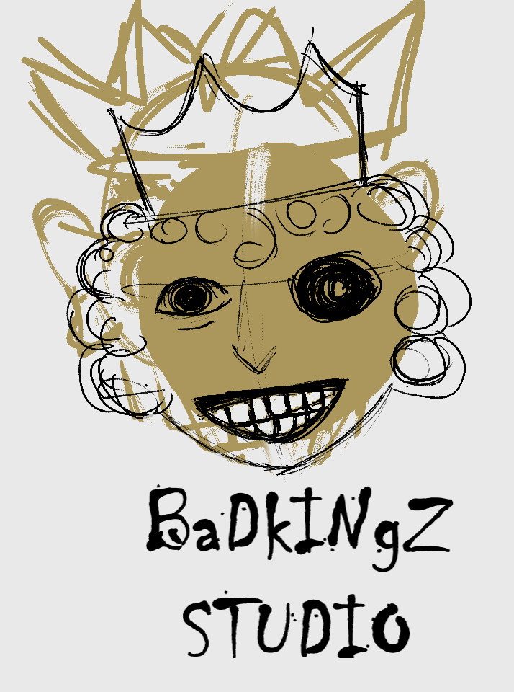

Datasheet

• Publisher: none

• Developer: BaDkINgZ

• Number of Full-time developers: 5

• Number of Contractors: 5

• Length of Development: 6 Weeks

• Release Date: 5/30/2017

• Platform: PC

• Development software used: Unity Game Engine, Monodevelop

• Development hardware used: Ranged over course of development from 400- 1000 MHz CPUs with 128-512 MB RAM

• Notable Technologies:

• Project Size: about 1900 lines of scripts, 12 sounds, 2 music tracks, 18 animations, about 80 pictures

Overview

• Game developed for class assignment by a group of 5 students

What went right

• Team was able to separate into clearly defined roles

• Development of game assets was done in parallel

• Got started with making game concepts early, so when the project was officially assigned, we got to work on the actual game quickly.

• Rapid prototyping resulted in quick decision and and design changes.

• Every member's contribution to the main idea was a major factor which cause the project to be complete in time.

• A defined timeline for individual work along with a perfect development management process.

• The current build of the game is tested rapidly to make it bug free.

What went wrong

• implementing the game assets into the game could not be done in parallel. Had to wait until one team member was done before working on another part. Other times, no one was working on it.

• For all of us, this was our first time using Unity, so it took a while to understand how it worked. Sometimes, we would spend hours trying to fix or get around a bug or try to figure out how a feature of Unity worked. These types of problems were something an experienced user could solve in minutes or avoid altogether.

• We were using different Unity versions throughout development, which caused some compatability issues.

• time constraints did not allow implementation of other game objective such as: multiple levels, multiple player, super hero mode and improved graphics.

• game menu could have been improved with high score and how to play options.